MEDIA RELEASE
MR-33-0314
Issue date: 21/03/14

Case IH expands CVT offering into Maxxum tractor range

Case IH has announced its Continuously Variable Transmission (CVT) technology is now available for the Maxxum® tractor line up, on the Maxxum 110, 120 and 130 CVT models. First introduced into the Australian market with the Puma family in 2008, Case IH CVT simplifies tractor operation while also delivering the best balance of power and fuel efficiency.
"Case IH continues to deliver on customer requests by taking the multi-purpose Maxxum tractor, which is known for its ability to handle large workloads, and furnishing it with technology to improve engine performance and fuel efficiency," says Peter Elias, Case IH Product Specialist for Tractors.
“And customers tell us they really appreciate how easy the Case IH CVT is to use, even for inexperienced drivers. There’s no programming required; you set the speed and direction you want to go and the tractor does the rest.”
Efficient Power Built In
CVT combines the stepless speed variability of a hydrostatic transmission with the mechanical efficiency of a traditional gear transmission.
“It delivers power to the ground efficiently at every speed, for the ultimate in smooth, stepless shifting—from creeper speeds as low as 30 metres per hour for vegetable growers, all the way up to 50 kilometres per hour for transport operations,” says Peter.
Case IH offers an active stop feature that is especially popular, according to Peter. “You simply pull the MultiFunction Handle all the way back, and it will stop the tractor without having to push the clutch. This makes it easier to operate the tractor, and it makes starting and stopping simpler than driving a car.”
This functionality also applies to the foot throttle and is especially useful when backing the tractor up to hitch to implements. Not only is this process easier, it’s also safer.
All Maxxum CVT tractors are equipped with standard Power Boost, which provides additional engine power of up to 20 horsepower to maintain working speeds in tough crop conditions or on inclines, and to provide more power for roading or for mobile hydraulics or PTO applications. Maxxum CVT tractors also feature increased hydraulic capacity for more responsive implement and steering control.
[continues]

Even Better Operator Environment
Adding to the ease of operation for new Maxxum MultiController models is an updated Case IH Multifunction Handle that simplifies operation.
Redesigned buttons are now raised and backlit, and sized to differentiate functions, based on feedback from operators. You can tell the buttons apart by touch alone to make operation even simpler.
Other cab enhancements for Maxxum CVT include a newly designed control panel recessed into the headliner, featuring AC controls, relocated into a more natural line of sight when operating the tractor. The headliner also has three additional slots – one for radio and two for additional storage.
Operators will also appreciate new left-hand soft trim, a storage net below the instructor seat, elastic straps on the instructor seat’s back rest and a deluxe radio standard with Bluetooth.
[ends]
Drawing on more than 170 years of heritage and experience in the agriculture industry, Case IH provides powerful range of tractors, combines and balers supported by a global network of highly professional dealers dedicated to providing our customers with the superior support required to be productive in the 21st century. More information on Case IH products and services can be found online at www.caseih.com.
More news stories and high resolution images at www.caseihpressroom.com.au.
Case IH is a brand of CNH Industrial N.V., a World leader in Capital Goods listed on the New York Stock Exchange (NYSE: CNHI) and on the Mercato Telematico Azionario of the Borsa Italiana (MI: CNHI). More information about CNH Industrial can be found online at www.cnhindustrial.com.

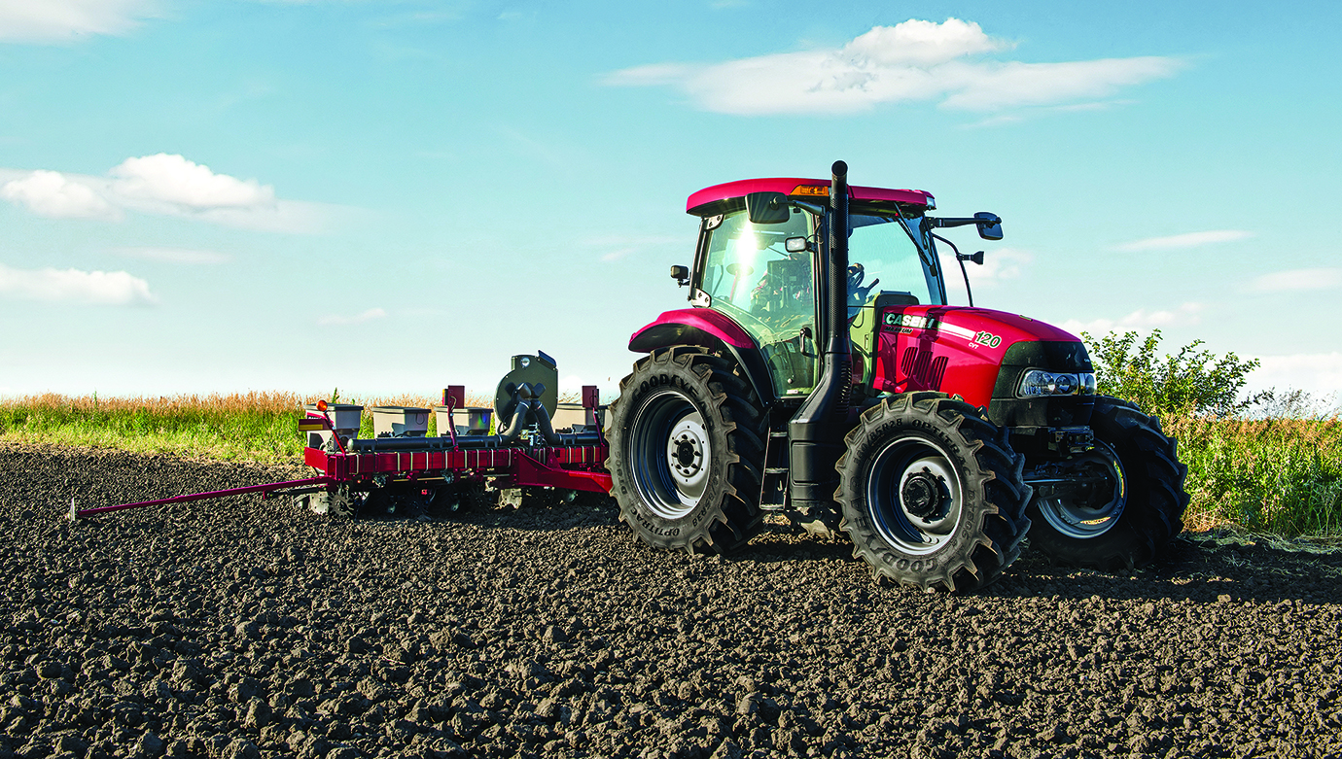

Photo Caption: Case IH continuously variable transmissions (CVT) technology is now available on Case IH Maxxum 110, 120 and 130 models, giving operators the best balance of power and fuel efficiency.

