MEDIA RELEASE
MR-67-0515
Issue date: 11/05/15

Proper servicing maximises productivity – and safety

With its combination of hazards and work context, farming can be one of the most dangerous industries in Australia.
As we approach a busy period of the year for growers and machinery, it is an ideal time to emphasise the importance of adequately maintained machinery and equipment to support on-farm safety. Improper machinery maintenance can lead to costly down time and lower productivity. However, equipment that is not serviced properly can also become an unnecessary danger to its operator. Farmers and contractors looking to make up time or feel they need to cut corners as a result of preventable breakdowns are also making themselves vulnerable to injuries or more dire situations.
According to Safework Australia, unsafe use of plant is a major cause of workplace injury and death, including from unguarded moving parts, being crushed by mobile plant, sustaining fractures while checking or using plant, and electrocution or burns.
It’s something Patrick McVeigh, Case IH National Aftersales Manager, has noted over his years of involvement with farm machinery.
“Farmers will talk about losing a finger, or the top of a finger, like other people talk about stubbing a toe. It’s part of the hazard of being a farmer, but the indication is they weren’t doing something safely. Too many times I’ve seen farmers trying to do something with a front end loader and a chain. Even at last year’s FarmSafe Australia conference, they discussed tractor deaths from rollovers and the lack of safe access platforms. New machinery is these days designed with safety in mind, but on older models additional safety features can be fitted by a qualified service technician, such as those at Case IH dealers.”
Equipment that is not maintained properly is hazardous — with severe consequences possible when it’s farm equipment. And just because they’re a skilled farmer says Patrick, it doesn’t follow that they’re skilled in mechanics.
As part of the push for safer farm workplaces, Australian WorkSafe authorities’ code of practice says “plant must be maintained and repaired according to the manufacturer’s specifications”.
[continues]

The Case IH dealer network provides customers with factory trained service technicians. They have the skill and experience required to correctly maintain and service Case IH machinery, so that the safety risks associated with operating these important farm assets is minimised. One such dealership in Geraldton, Western Australia is doing just that each and every day. Purcher International’s Steve Purcher understands the importance of regular maintenance and service to maximise operator safety.
“WorkSafe is trying to stop preventable injuries. They don’t want untrained people ‘mucking around’ inside engines or the mechanicals of a harvester or baler or similar. The best people for those jobs are trained technicians. The number of trained mechanics missing fingers is very rare; they know all the safety aspects to ensure the machine’s not going to turn on accidentally when they’re working on it, and then when they’re finished, that everything is working properly and there are no hidden issues internally. You can’t necessarily see internal problems until something fails. But a weakening bearing in a gearbox or differential say, will be picked up during a service when oil samples are taken and fixed before it becomes a major issue.”
Purcher International prides itself on its workshop.
“Technological advances mean computer diagnostics are necessary, but we also need our specialised equipment for the safety of our mechanics and the benefit of our customers — including their own safety when they’re using it. Our equipment and trained support staff make it cheaper for our customers in the end because the job is done properly once: the first time.”
Steve says on top of the safety aspects, properly maintained farm machinery has profit benefits.
“Firstly it will work constantly when farmers need it. Operations such as seeding, harvesting, spraying and so on, are very time critical; breakdowns result in production and income losses.
“Secondly, in the long term, properly maintained farm machinery means better resale value.”
Contact your local Case IH dealer about the genuine parts and service offers available to minimise unnecessary downtime. Your local Case IH dealer can provide information on the importance of having your machinery and equipment serviced by certified, factory trained technicians, keeping you safe and your machinery productive.
[ends]

Drawing on more than 170 years of heritage and experience in the agriculture industry, Case IH provides a powerful range of tractors, combines and balers supported by a global network of highly professional dealers dedicated to providing our customers with the superior support required to be productive in the 21st century. More information on Case IH products and services can be found online at www.caseih.com.
Case IH is a brand of CNH Industrial N.V., a World leader in Capital Goods listed on the New York Stock Exchange (NYSE: CNHI) and on the Mercato Telematico Azionario of the Borsa Italiana (MI: CNHI). More information about CNH Industrial can be found online at www.cnhindustrial.com.
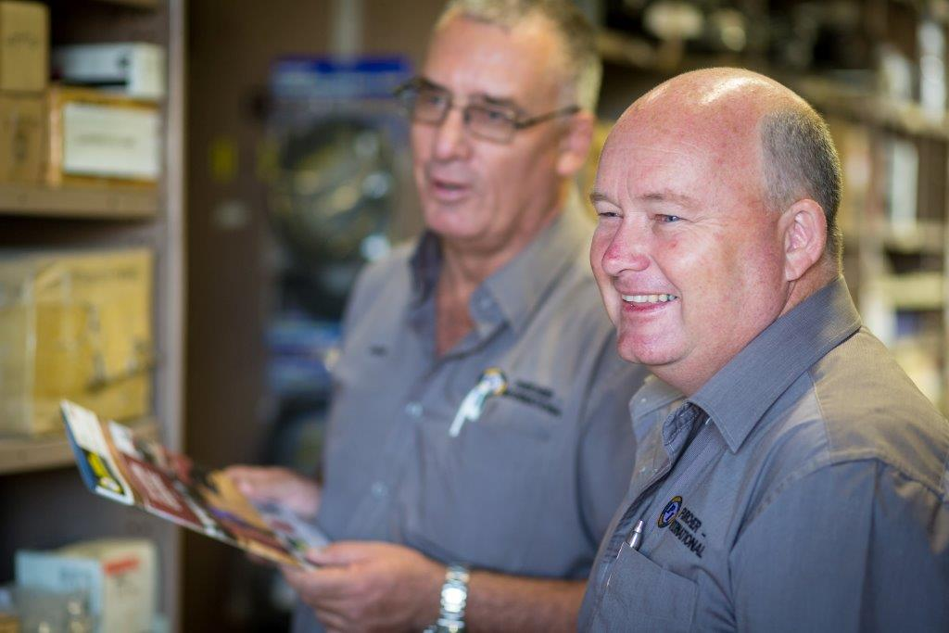
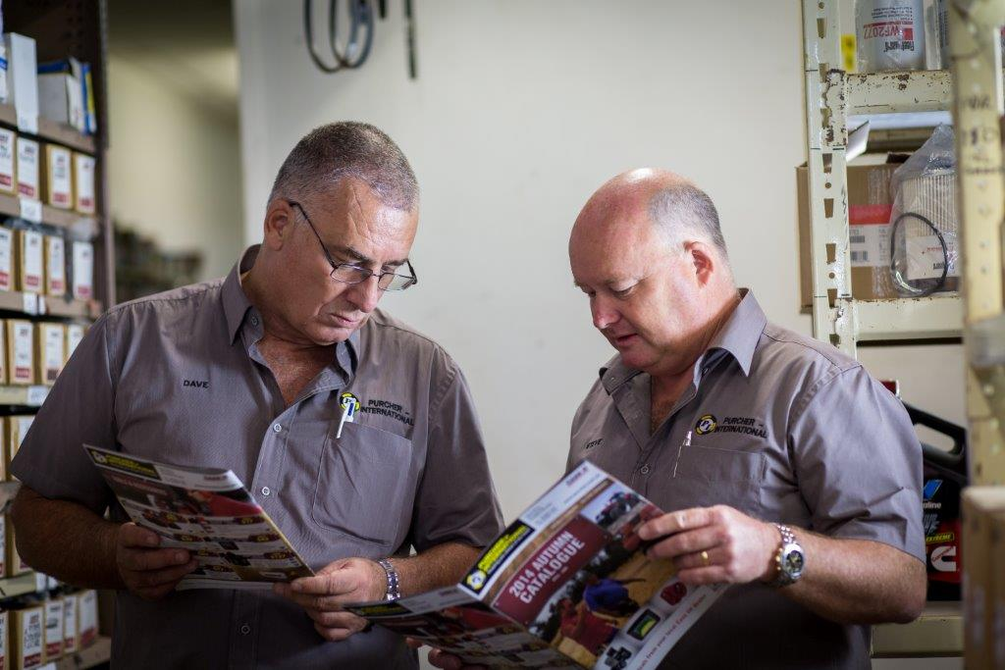
Photo caption: Steve Purcher (right), Dealer Principal of Purcher International at Geraldton in Western Australia, says on top of the safety aspects, properly maintained farm machinery has profit benefits.

http://www.safeworkaustralia.gov.au/sites/SWA/about/Publications/Documents/759/Work-related-injuries-fatalities-farms.pdf
Point 3.7, “Maintenance, repair and cleaning of plant” in Managing the risks of plant in the workplace, Code of Practice, July 2014

