MEDIA RELEASE
MR-74-0915
Issue date: 1/10/15
Lambrook goes with Case IH tracks and rotary technology
William Adams, owner of Lambrook Pastoral Co. at Mullaley, has made a well-considered decision to move to track technology, across all of his tractors.
“Over the past few years I have closely observed the replacement of wheeled equipment with tracks,” said Mr Adams.

According to Mr Adams, “The new Case IH Steiger Rowtrac was displayed for the first time at AgQuip in 2014. We were very impressed with the new technology and traded in our six-year old Magnum 305 for a new Steiger Rowtrac 450.”

“This was only after a very thorough study of tracks versus wheels, and consultation with the new Case IH dealership in Gunnedah, Wideland Ag and Construction, with whom we have a great relationship”, he said.

According to Jason Wood, Branch Manager of Wideland Ag and Construction at Gunnedah, “That is what is so great about Case IH – their commitment to getting things right. The Rowtrac really is the next evolution of the Quadtrac with an emphasis on ironing out any issues older tracked models had.”

The Case IH Steiger Rowtrac is a game changer. It is one of the highest horsepower tractors commercially available in a row crop track machine, to handle the largest implements on the market. Steiger tractors are famous for superior power and performance, no matter what the conditions and the Rowtrac 400, 450 and 500 tractors provide convenient configurations to match every farm operation’s high-horsepower needs.

“We are so impressed with the Case IH Steiger Rowtrac 450, particularly the way it can easily transfer the horsepower to the ground, compared to wheels. The compaction footprint under tracks is so noticeably less than that of wheels, which sink into our beautiful soft black soil, and dig a large mound of earth in front of each wheel. This mound makes the task equivalent to constantly going up a hill, obviously requiring more horsepower, which means more fuel and horsepower wasted.”

The compaction of tracks is much less, leaving much more horsepower to pull larger and heavier equipment. According to Mr Adams, “I believe you can get away with approximately a ten to fifteen per cent less horsepower rated tractor on tracks, to do the same job as if it were on wheels. This is a clear saving on initial outlay to purchase, and ongoing fuel savings.”
“The Steiger Rowtrac 450, being well-balanced between front and rear, really looks the part. It is a physically large tractor, but leaves a small footprint. At the end of each run, it can make a 180 degree turn without leaving the large and messy berm, that single track, skid steer type tractors leave. It really makes turning easy, even the tightest of turns”, he said.

“The innovative track technology is so outstanding that we were the first to purchase in our district - the latest release from Case IH, a rear-tracked Magnum Rowtrac 340 CVT, replacing our five-year old Magnum 305.

“Our decision to go with the CVT transmission over the well-proven power shift has so far been the right one. We believe this transmission is the way of the future, and ideal for a tractor with varied outputs”, he said.

Magnum Rowtrac tractors are designed to strike the perfect balance, with front tyre options that fit your row width and soil type and an oscillating rear-track design that keeps the power on the ground through the tightest turns.

“In engineering parlance there is a saying ‘if it looks right, then it is most probably right.’ These new tracked tractors look right to me. I am a firm believer that tracks are here to stay and it won’t be long before all of the larger gear will have them,” Mr Adams said.

Four years ago Mr Adams made the move to a Case IH combine harvester and earlier this year traded in the Axial-Flow 8120 on duals for a new 8230, on three metre spacings.

“Once again, we were most impressed with the Case IH. We are aware that Case IH manufactures a header on tracks and will seriously look at going this way when it becomes more readily available in Australia,” said Mr Adams,

“The rotary technology that Case IH has with its headers is exceptional and the extra horsepower in the new models will be much appreciated in heavier crops, which we hope to have this year.”

[ends]
Drawing on more than 170 years of heritage and experience in the agriculture industry, Case IH provides a powerful range of tractors, combines and balers supported by a global network of highly professional dealers dedicated to providing our customers with the superior support required to be productive in the 21st century. More information on Case IH products and services can be found online at www.caseih.com.

More news stories and high resolution images at http://www.caseih.com/anz/en-au/service/press/news-room.

Case IH is a brand of CNH Industrial N.V., a World leader in Capital Goods listed on the New York Stock Exchange (NYSE: CNHI) and on the Mercato Telematico Azionario of the Borsa Italiana (MI: CNHI). More information about CNH Industrial can be found online at www.cnhindustrial.com.

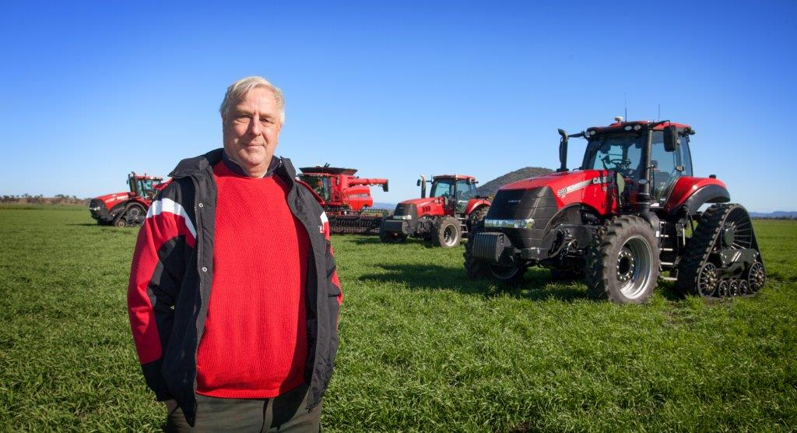
Photo Caption: William Adams, owner of Lambrook Pastoral Co. at Mullaley, has made a well-considered decision to move to track technology, across all of his tractors.

