MEDIA RELEASE
MR-79-1115
Issue date 20/11/15

Australia’s Most Popular Case IH Factory Celebrates 50 Years of Operation

Case IH celebrates an important milestone this year, marking 50 years of operations at its Grand Island plant in Nebraska, United States.

The plant manufactures two Case IH combine harvester model families for the Australian market at the site: the Axial-Flow 140 Series and the Axial-Flow 240 Series, as well as Case IH self-propelled windrowers and disc mower conditioner fronts. Since opening, the facility has tripled in size from 30,100 sq. metres to 91,044 sq. metres with approximately 35% of its production exported to 40 countries around the world.

Case IH Product Manager – Hay and Harvest, Tim Slater, said over the past 50 years of operation the plant has continued to evolve, producing high-quality machines designed to increase productivity and reliability for growers.

“With the release of the new Axial-Flow 240 Series combine last year, growers are experiencing greater levels of performance, productivity and profitability”, said Tim, “Not only do growers get a powerful, fuel-efficient machine designed to optimise yield for bigger profits, but they also get a reliable combine that has a strong ‘American-made’ reputation for quality, bringing an impressive resale value when it’s time to upgrade”.

The Grand Island plant has long been a favourite of Australian travellers, with hundreds touring the facility over the years.

“The Grand Island plant provides Australian customers with a rare insight into the quality manufacturing process from start to finish, demonstrating the latest innovations and technology”, said Tim.

“By forward ordering their Axial-Flow combines, customers can have them built to unique specifications and if visiting the US, can tour the plant as their own combine rolls off the production line”.

The state-of-the-art production factory was originally built to produce combines for the North American market. The first unit came off the production line at the Grand Island plant on 22 November 1965, a mere five months after construction began.

The Grand Island facility operates as one of CNH Industrial’s state-of-the-art Centres of Excellence, hosting current product design, manufacturing, and testing all in one location. Several business units make up the manufacturing area of the Grand Island plant, including fabrication, welding, paint and assembly. Each area uses modern technology to aid in their process, including an automotive grade e-coat paint system, laser cells, robotic welders and wireless testing systems.

The Grand Island plant is one of 12 manufacturing plants in CNH Industrial’s North American footprint, which includes 13 research and development centres.

[ends]

Drawing on more than 170 years of heritage and experience in the agriculture industry, Case IH provides a powerful range of tractors, combines and balers supported by a global network of highly professional dealers dedicated to providing our customers with the superior support required to be productive in the 21st century. More information on Case IH products and services can be found online at www.caseih.com.

More news stories and high resolution images at http://www.caseih.com/anz/en-au/service/press/news-room.

Case IH is a brand of CNH Industrial N.V., a World leader in Capital Goods listed on the New York Stock Exchange (NYSE: CNHI) and on the Mercato Telematico Azionario of the Borsa Italiana (MI: CNHI). More information about CNH Industrial can be found online at www.cnhindustrial.com.

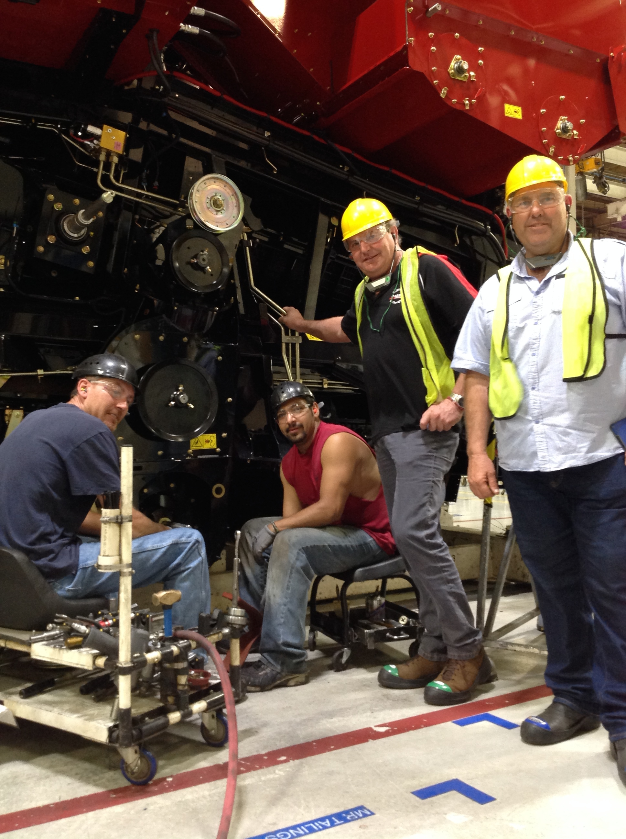
Photo Caption: David Barlow, Jerilderie NSW, and Peter Caldwell, Badgebup WA, with employees at the Case IH Axial-Flow combine factory in Grand Island – just one of the stops on the Axial-Flow USA Tour in August last year.

